🧭 Common Types of Network Topologies:
# Source: AI Source: Provided by: [Data Path: Persons Table -> ID Column: 1, Name_En Column: Motasem Essam] -> From: [ChatGPT] on [12/18/2025]
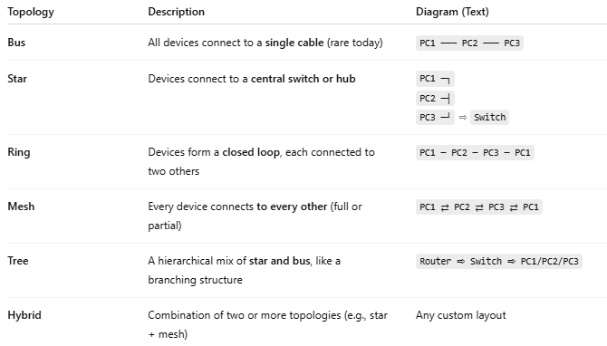

Topology | Description | Diagram (Text)
Bus | All devices connect to a single cable (rare today) | PC1 ─── PC2 ─── PC3
Star | Devices connect to a central switch or hub | PC1 ─┐PC2 ─┤PC3 ─┘ ⇨ Switch
Ring | Devices form a closed loop, each connected to two others | PC1 ─ PC2 ─ PC3 ─ PC1
Mesh | Every device connects to every other (full or partial) | PC1 ⇄ PC2 ⇄ PC3 ⇄ PC1
Tree | A hierarchical mix of star and bus, like a branching structure | Router ⇨ Switch ⇨ PC1/PC2/PC3
Hybrid | Combination of two or more topologies (e.g., star + mesh) | Any custom layout

